**EXERCISE NO:2**

**DATE: 15/10/2020**

**AIM:**

To count the number x in a given list of numbers.

**PROGRAM:**

def countX(lst,x):

count = 0

for ele in lst:

if ele == x:

count = count + 1

return(count)

lst = [5,5,4,3,5,5,6]

x = 5

print("{} has occured {} many times".format(x,countX(lst,x)))

**LINK:** <http://103.53.53.18/mod/vpl/forms/edit.php?id=230&userid=1695>

**OUTPUT:**

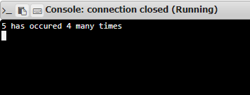

**RESULT:**

Thus the number of x in the given list of numbers is displayed.